DATE: 26.10.2018
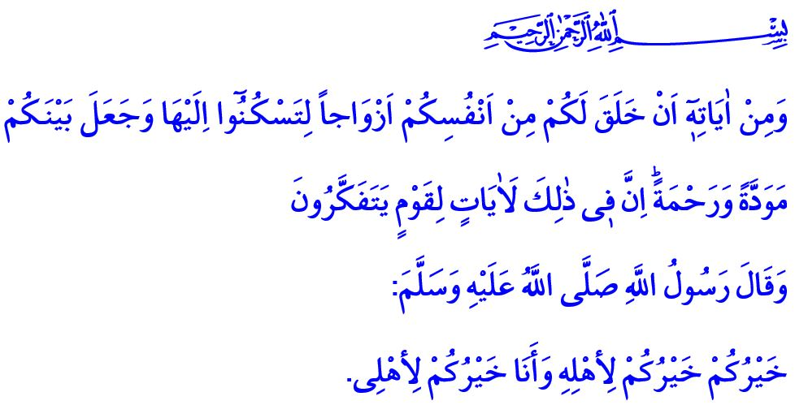
COMPASSION AND KINDNESS LANGUAGE
IN THE FAMILY
Honorable Muslims!
Islam has put an end to any kind of bad words and habits of jahiliyya (period of ignorance), and built an “age of bliss”, in which faith and good morality prevail. The Companions of the Prophet (saw), which were the first to embrace of Islam, were a distinguished group consisting of good-natured and eloquent people with good intentions. What befits the following generations of them and to us today is to follow the footsteps of the noble Companions (ra). We should reflect their lifestyle shaped according to the Qur’an and developed according to the Sunnah; and be the pioneers of good morality, compassion, and mercy.
Valuable Believers!
Our closest people deserve to hear the most beautiful words from us. Our family is most worthy of courtesy, tolerance, they deserve the most attentive attitudes with love and respect. In this regard, our Prophet (saw) said, “The best of you is the one who is best to his family, and I am the best of you to my family…”
It is invaluable that the Messenger of Allah (saw), portrayed his relationship with his own family established on kindness and beneficence as an example to us. Because family is the warmest atmosphere in which we can experience love, peace and trust throughout our lives.
Esteemed Believers!
Through our families, Allah the Almighty (swt) grants us the pleasure of being grandparents, spouses, children, grandchildren, brothers, or sisters. Family is the beauty of the mother’s heart, and the abundance of father’s home. It is the depth of love and loyalty between spouses. It is the width of the reverence and kindness that children show to their parents. Our Almighty Lord (swt) informs us of the importance of a precious treasure as family in the Holy Qur’an as, “And of His signs is that He created for you from yourselves mates that you may find tranquility in them; and He placed between you, affection and mercy. Indeed, in that are signs for a people who give thought.”
Honorable Muslims!
A peaceful family is established with love and sacrifice. It is kept alive with justice and conscience. It is protected by friendship and mercy. Even in the most troubled moments, a couple of words of conciliation tighten the bonds in the family back. If respect towards each individual prevails in a family, mercy speaks while violence quiets. In a family where all people, women and men, are put on the shield of mercy, no one can hurt one another even through implication.
Indeed, our Beloved Prophet (saw) never hurt anyone throughout his life. He was always understanding, patient, kind and tolerant towards his wives. He invited us to see the positive aspects and be fair by saying, “A believer should not hate his/her spouse; if they dislike one of his/her characteristics, he/she will be pleased with another.”
Honorable Muslims!
Good believers appreciate the value of the family members who suffer the difficulties and sorrows of life with them as well as sharing their happiness. They realize that they are entrusted to us besides being a blessing of Allah for us. They comprehend that being a believer, which means being a person “from whose hand and tongue people are safe”, begins in the family.
A good spouse is committed to the promise s/he made when s/he got married; they adhere to their covenant. A good father is loved in his family for his just and merciful behaviors. He walks with family members on the way of good, always in unity, arm-in-arm, and shoulder to shoulder.
Dear Muslims!
Peace and happiness in the family becomes permanent through healthy communication. Our Beloved Prophet (saw) said, “…he who believes in Allah and in the last day should speak good or keep silence.”, and always recommended believers to speak of good and pursue the good. As the addressees of this advice, we should not withhold our smiling face, kind words, appreciation, and gratitude from our family.
Esteemed Believers!
Let us once again remember the value of our family, with whom we spend the life journey together, with its ups and downs. Let us be affectionate and kind to our spouses and children. Let us not cut off our nose to spite our face. Let us neither hurt people nor get hurt ourselves. On the contrary, let us adopt being merciful and virtuous to everybody and in any case as a principle in our lives. Let us not be the cause of unrest in the family, but the guarantee of happiness and trust. Let us keep on saying this prayer that in taught to us by our Lord (swt) in the Holy Qur’an: “Our Lord, grant us from among our wives and offspring comfort to our eyes, and make us an example for the righteous.’”

Tirmidhi, Manaqib, 63.
Rum, 30/21.
Muslim, Rada’, 61.
Abu Dawud, Adab, 122, 123.
Furqan, 25/74. General Directorate of Religious Services

